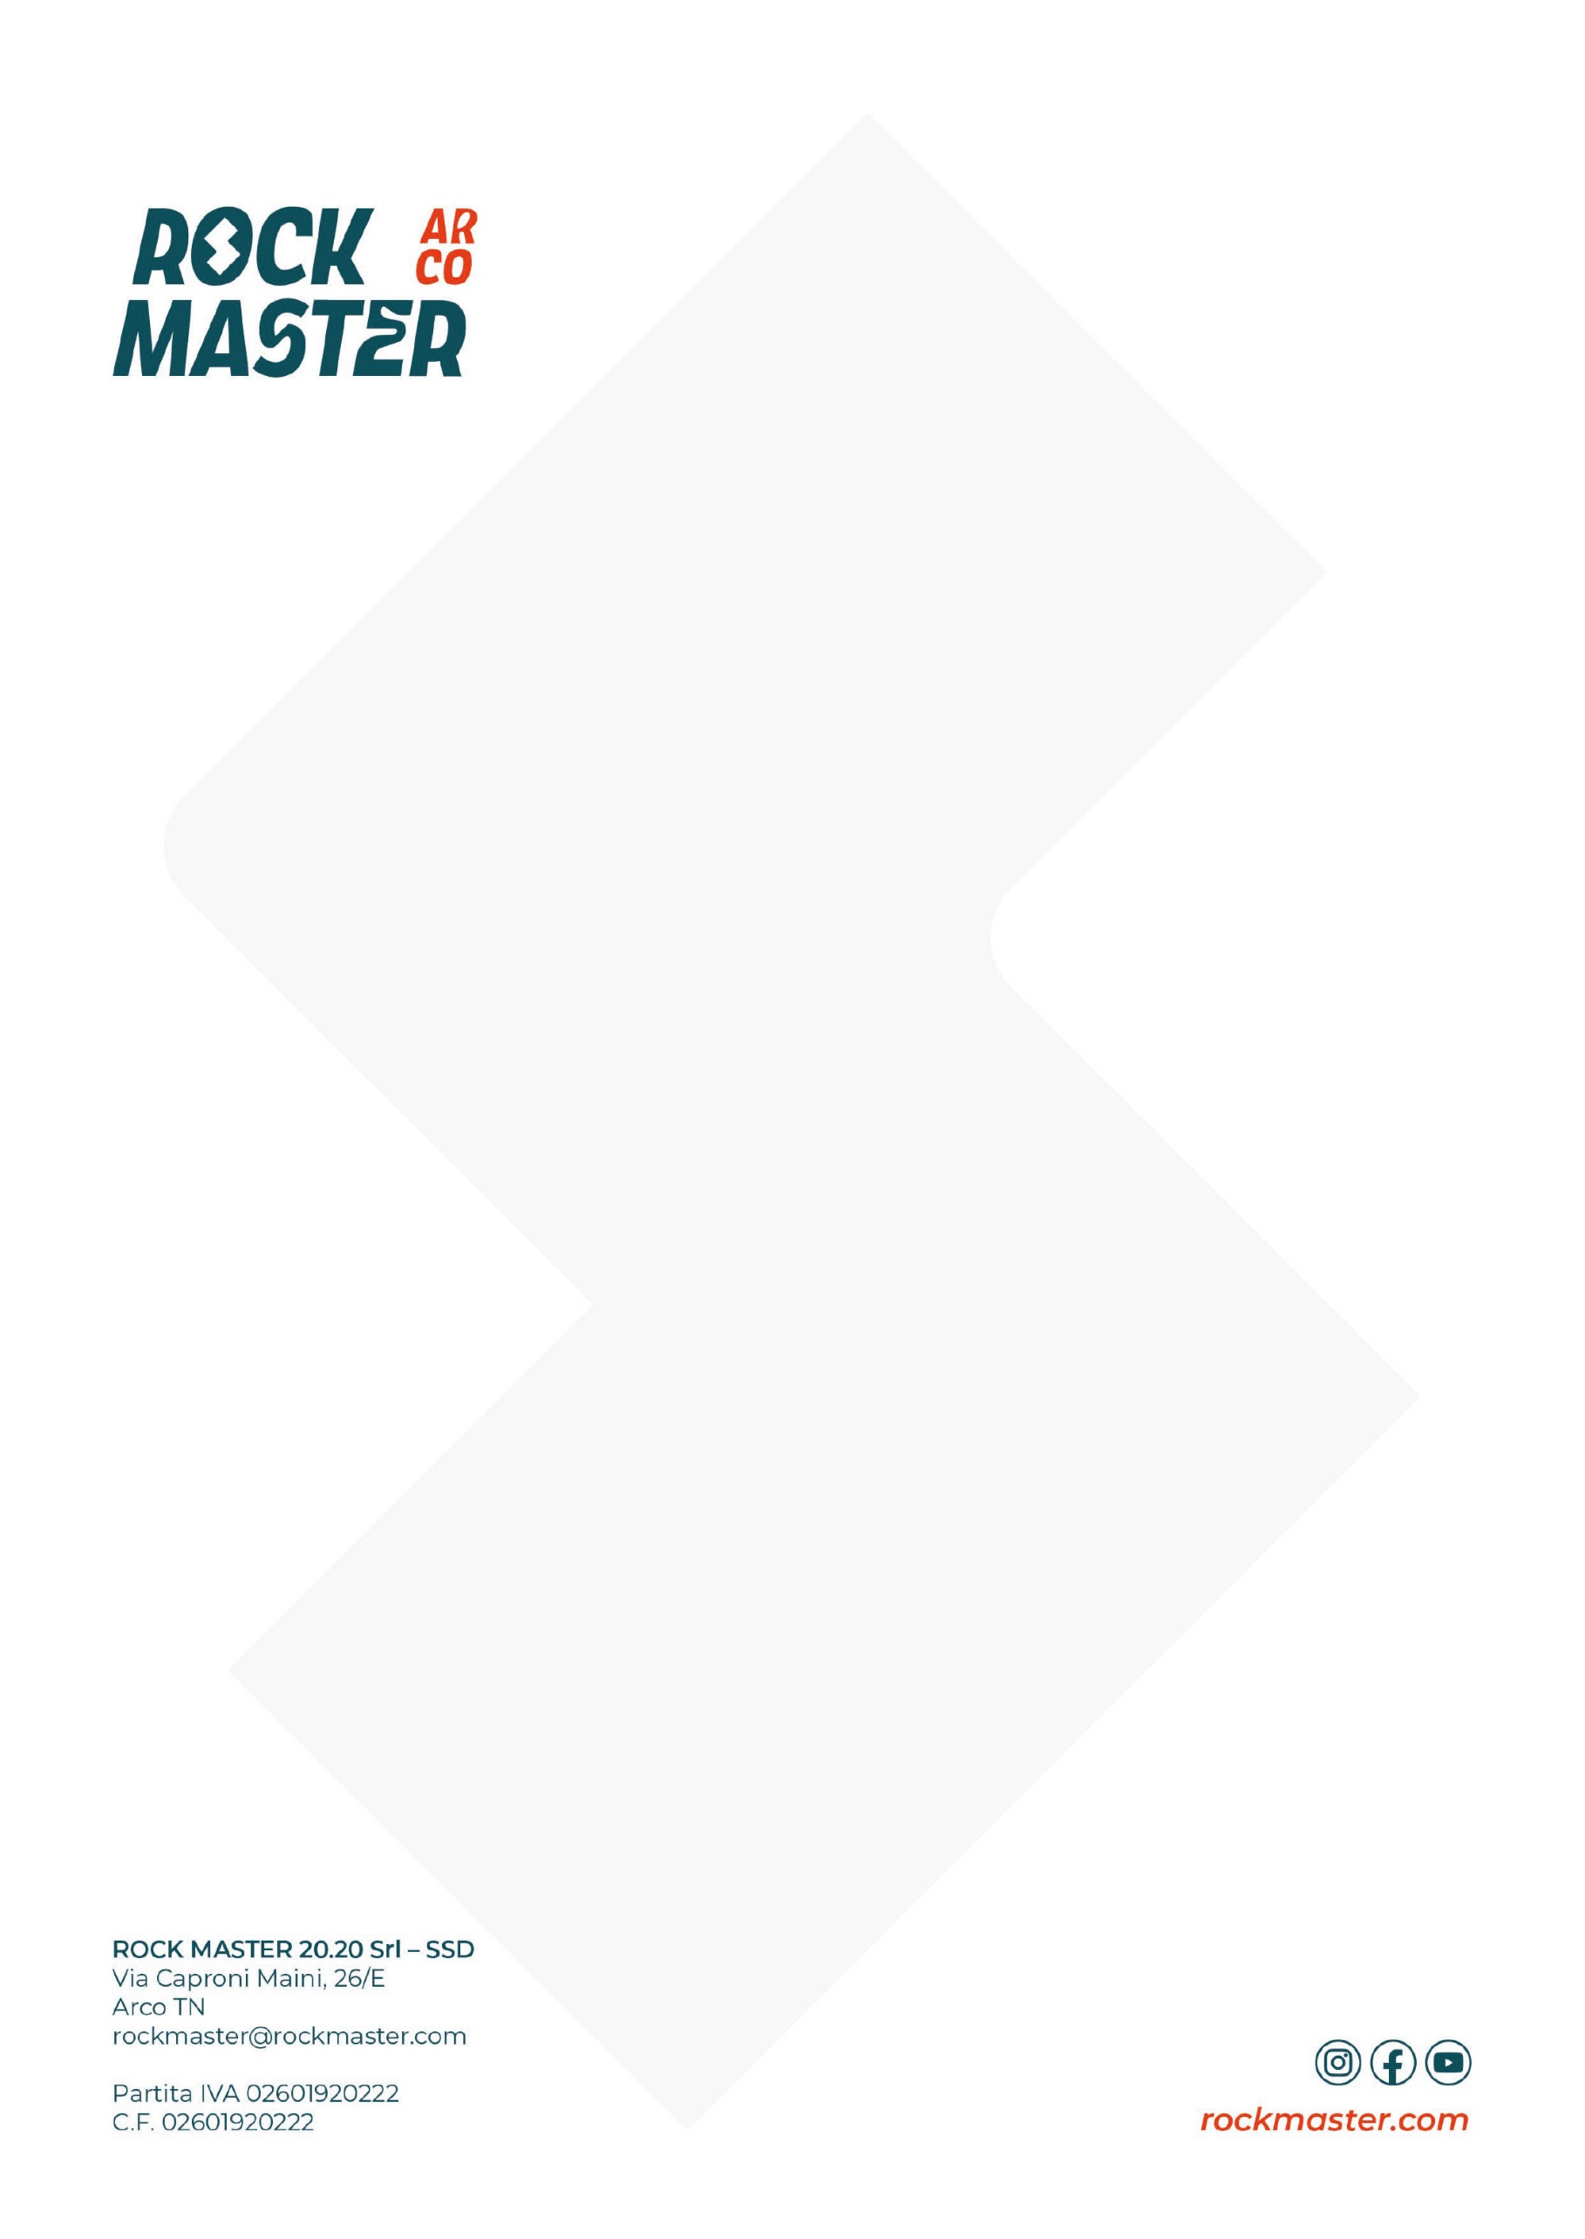
PROGRAMME

FIRDAY, OCTOBER 2
14:00 – 20:00 Rock Master Village opening
14:00 – 19:00 Let’s play
15:00 Official opening ceremony
15:30 – 16:30 Lead Duel women’s warm-up
16:30 – 17:30 Lead Duel men’s warm-up
18:00 Yoga for climbers with Sara Grippo
19:00 – 19:30 Athlete presentation & bib draw
20:00 Lead duel qualifications
21:15 – 22:15 Lead duel finals

SATURDAY, OCTOBER 3
09:00 Yoga for climbers with Sara Grippo
10:00 – 20:00 Rock Master Village opening
10:00 – 19:00 Let’s play
10:00 – 11:00 KO Boulder women’s practice sessions
11:00 – 12:00 KO Boulder men’s practice sessions
15:00 – 17:00 FASI Speed Record Hunters
20:00 – 22:00 KO Boulder

SUNDAY, OCTOBER 4
09:00 – 12:00 The Fun Bloc - amateurs
10:00 – 18:00 Rock Master Village opening
10:00 – 18:00 Let’s play
13:30 – 17:30 The Fun Bloc – U15
18:00 The Fun Bloc U15 prize-giving ceremony

